**CREATING IBM CLOUD SERVICE**

|  |  |
| --- | --- |
| Date | 25 October 2022 |
| Team ID | PNT2022TMID27037 |
| Project Name | Smart waste management using IOT in Metropolitan cities |

**AIM:**

To create IBM Cloud Service.

**STEPS TO BE FOLLOEWD**

Step 1: Visit to the ICT Academy Skills Network Page by clicking on the link given below:

Link:

https://courses.ictacademy.skillsnetwork.site/courses/course-v1:IBMDeveloperSk illsNetwork+CC0103EN+v3/course/

Step 2: Click on register.

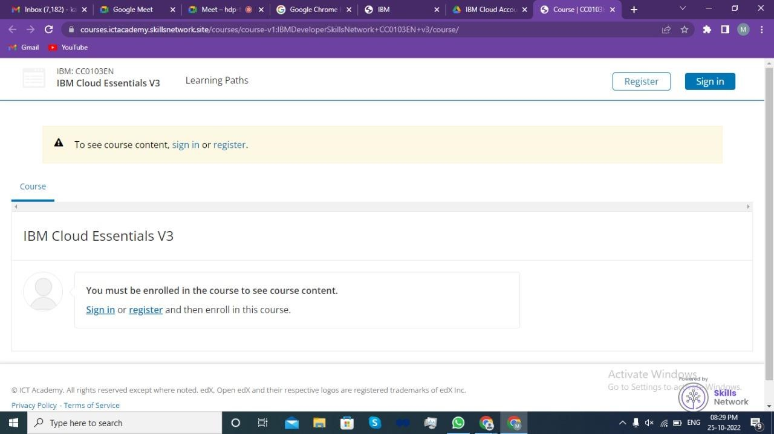

3: Fill the details for creating an account.

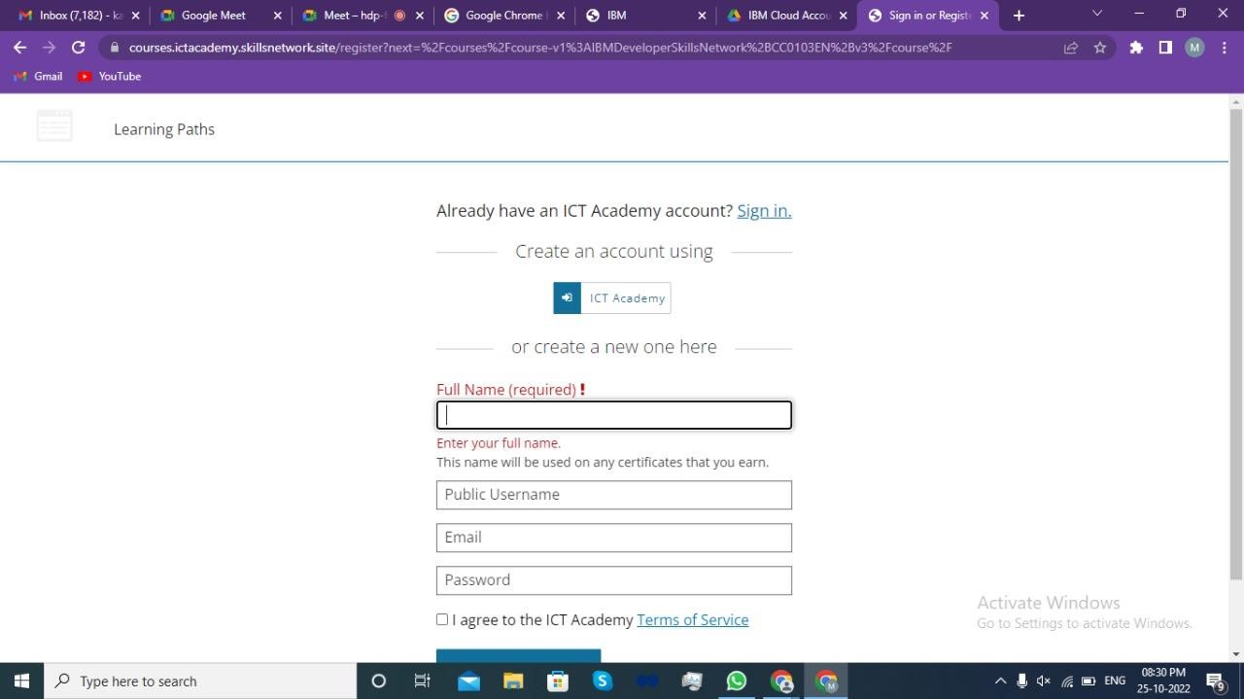

Step 4: Click on Enroll Now button to enter the course.

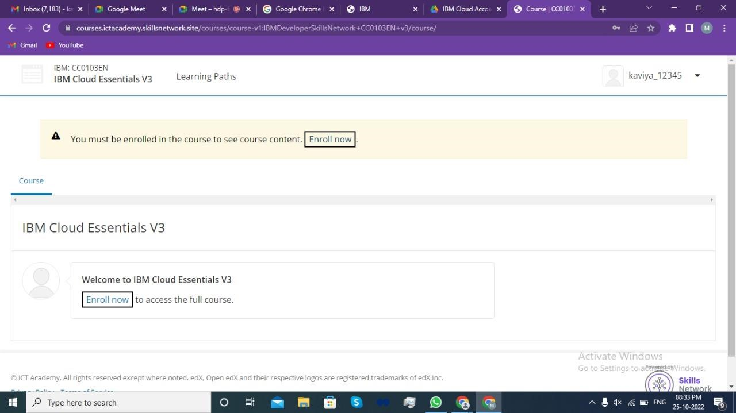

5: Expand Module-1

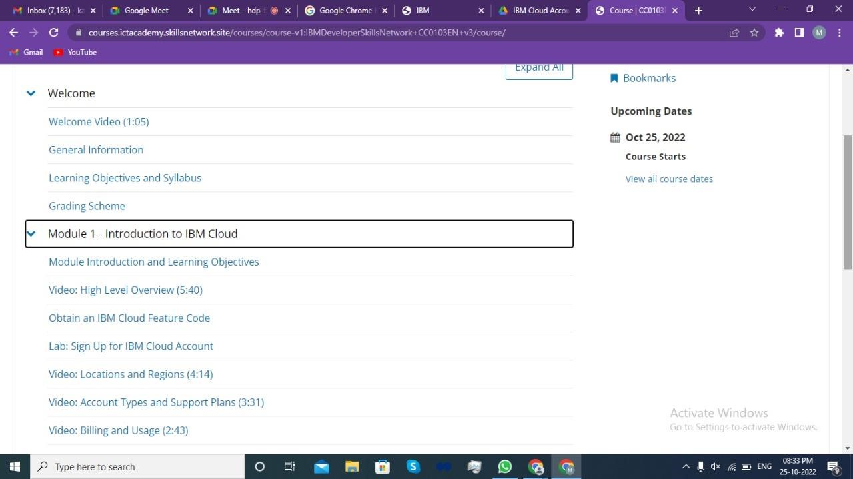

Step 6: Click on Obtain an IBM Cloud Feature Code.

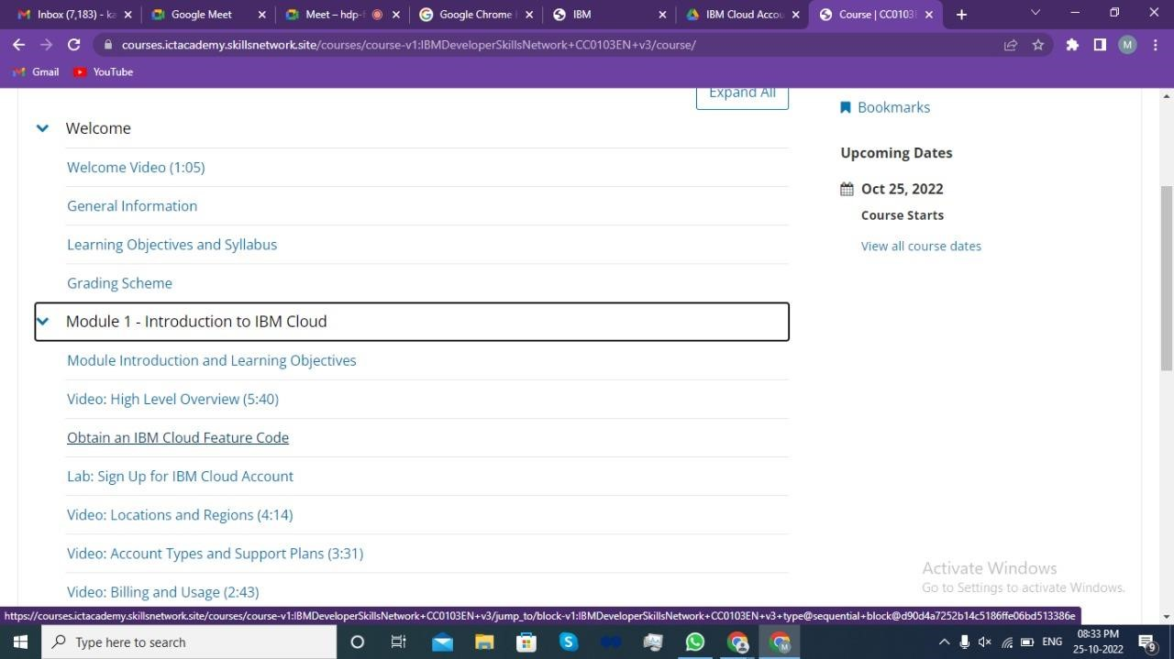

7: Scroll down and click on the open tool to get the feature code for creating an IBM cloud account.

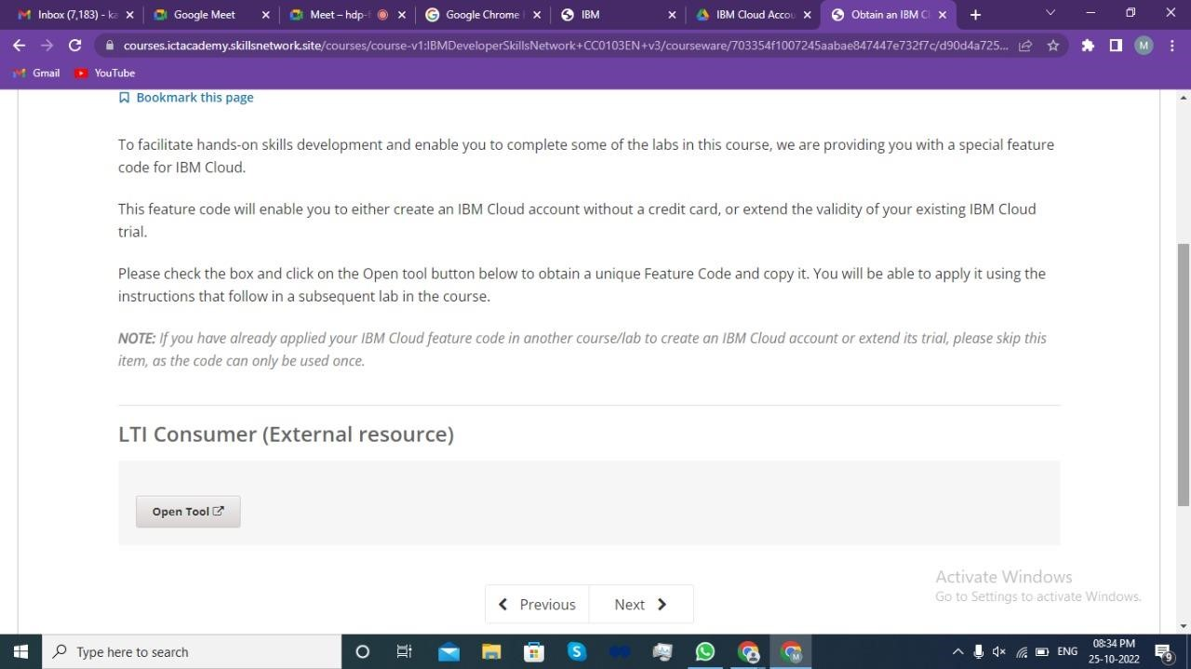

Step 8: Click ok on the popup message to proceed to the next page.

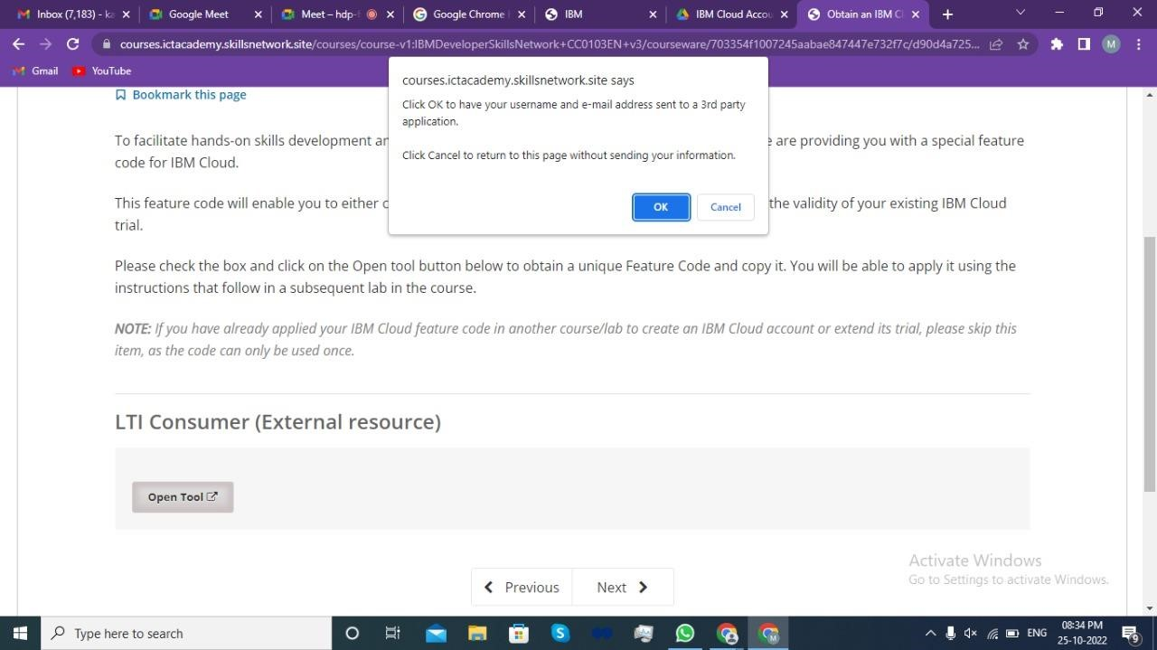

9: Click on activate your trial account for 395 Days with the feature code.

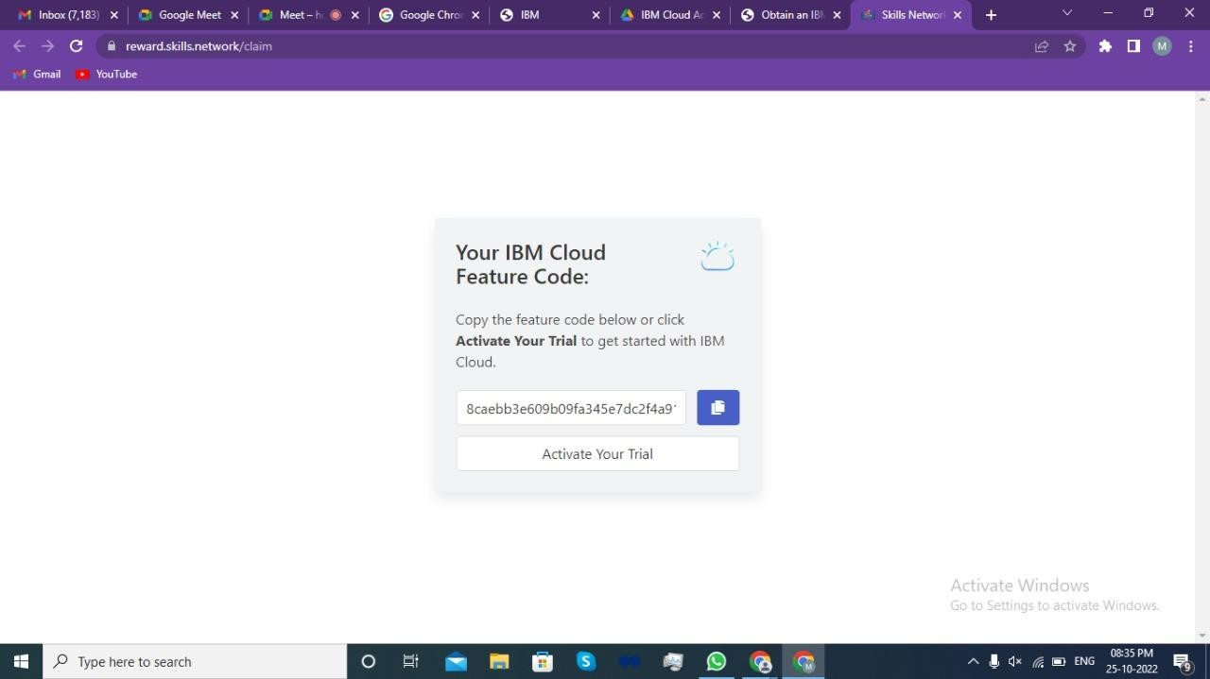

Step 10: Provide the email id & password used for ICT Academy account creation and click on next to get the OTP on the registered email id.

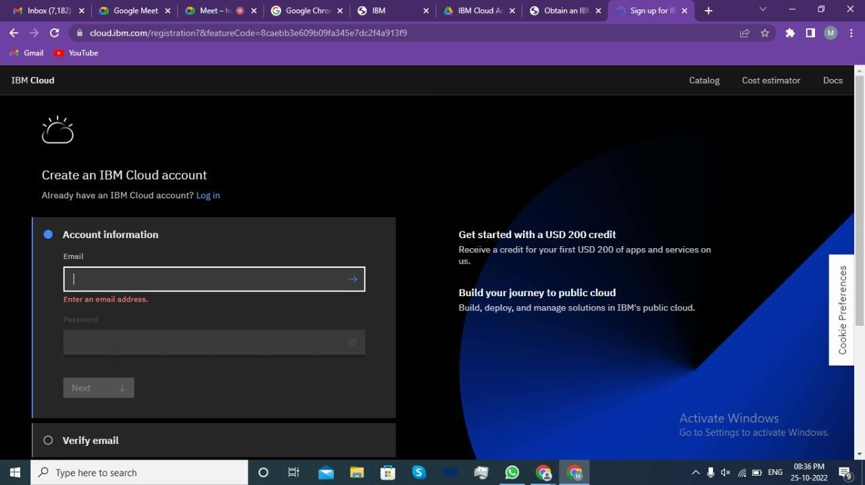

Step 11: Provide the received OTP on the registered email id and click on next.

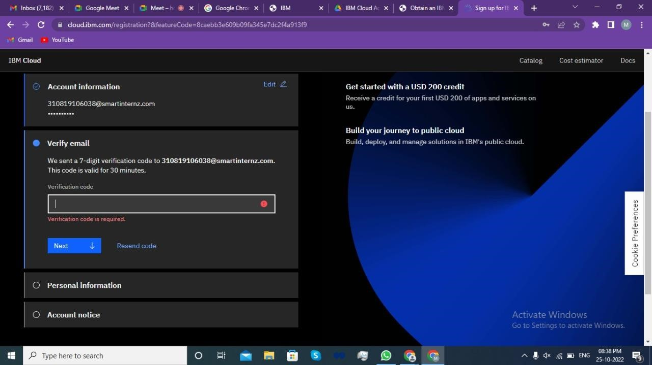

Step 12: Provide personal information and click on next.

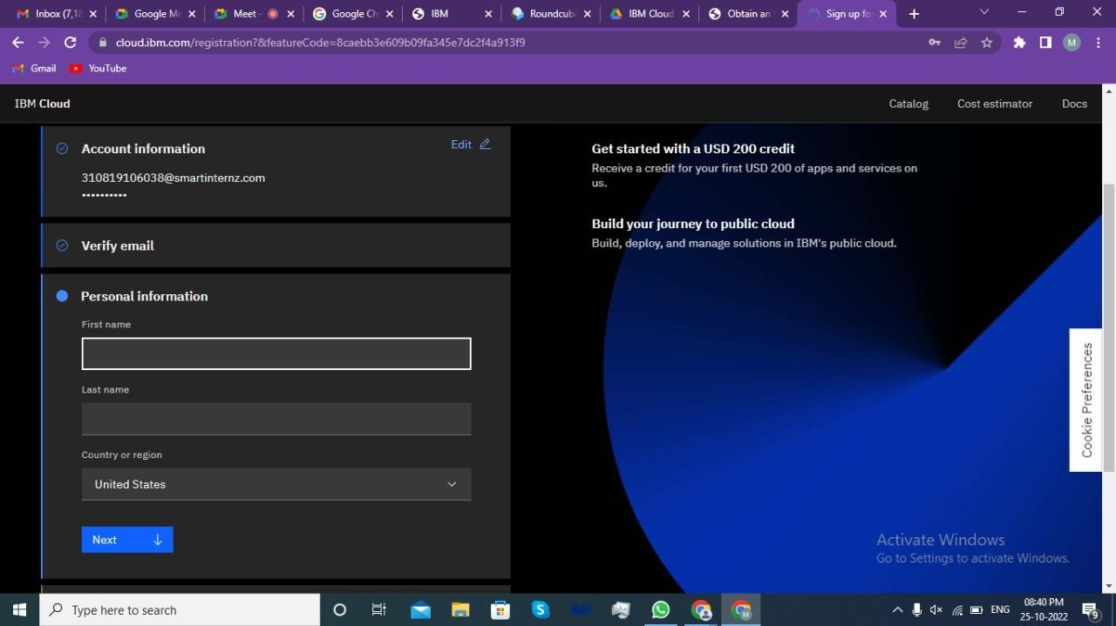

Step 13: Accept the terms and conditions then click on continue.

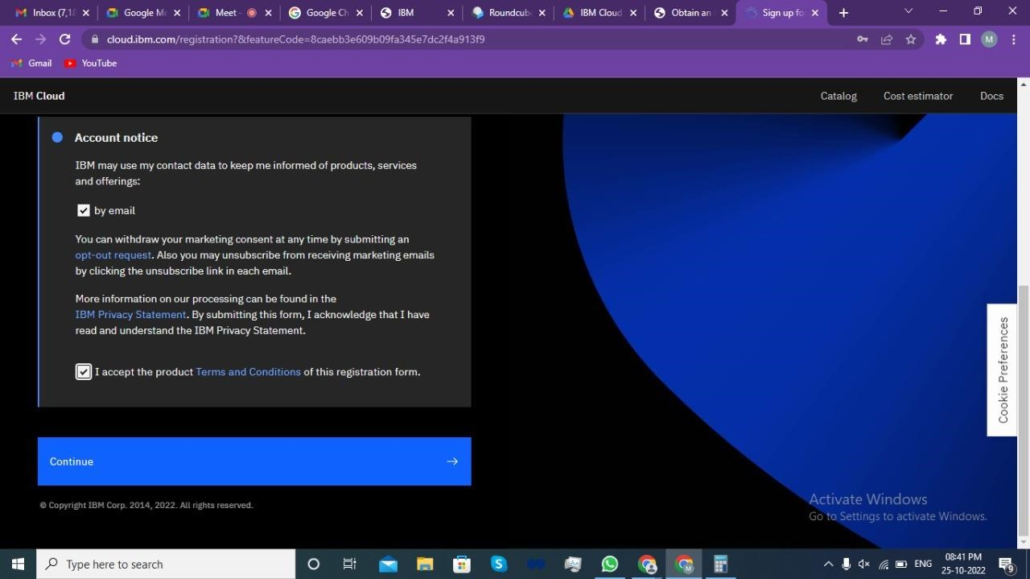

Step 14: Review account privacy notice mark the checkbox then click on continue.

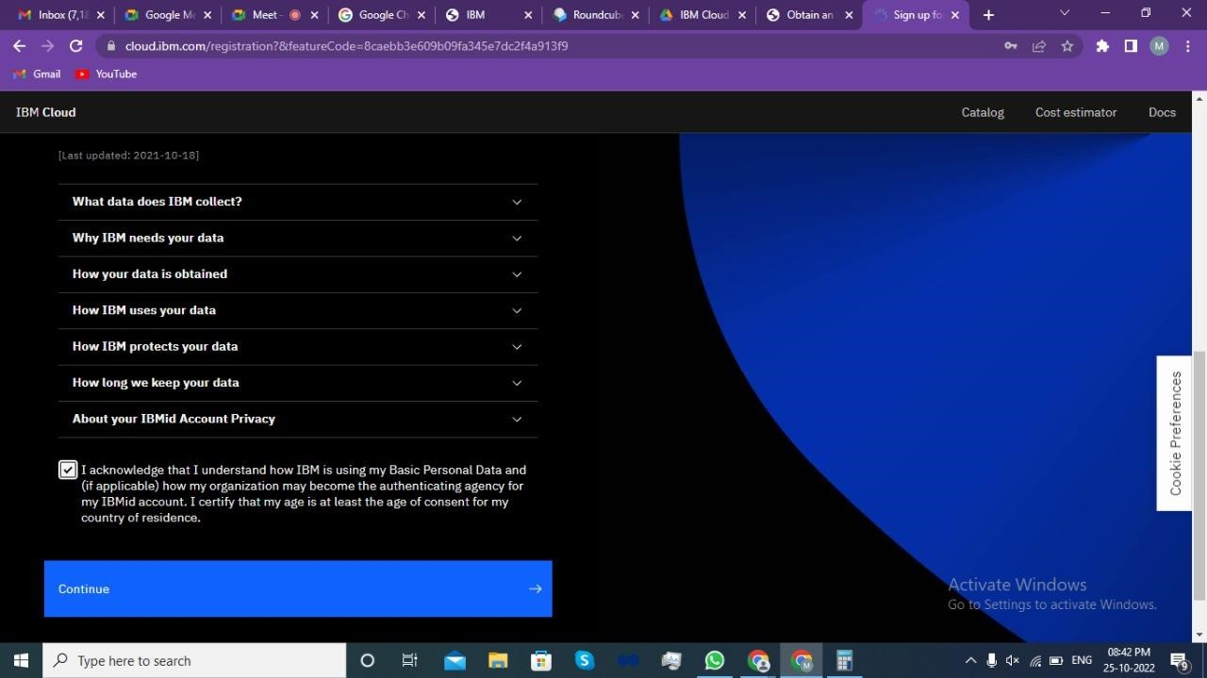

Step 15: To get the Future Code, Go to the Website

https://www.ibm.com/academic/home

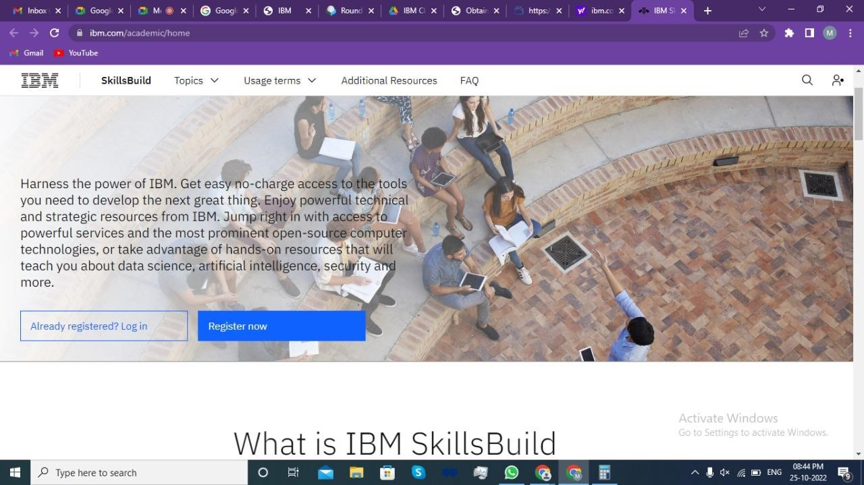

Step 16: Click on Register Now.

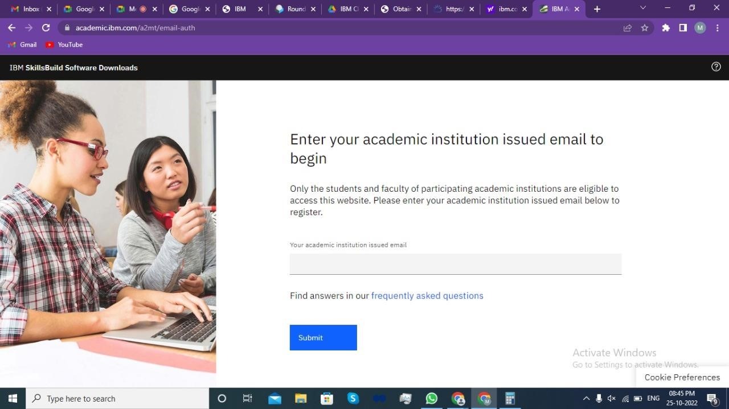

Step 17: Fill the details.

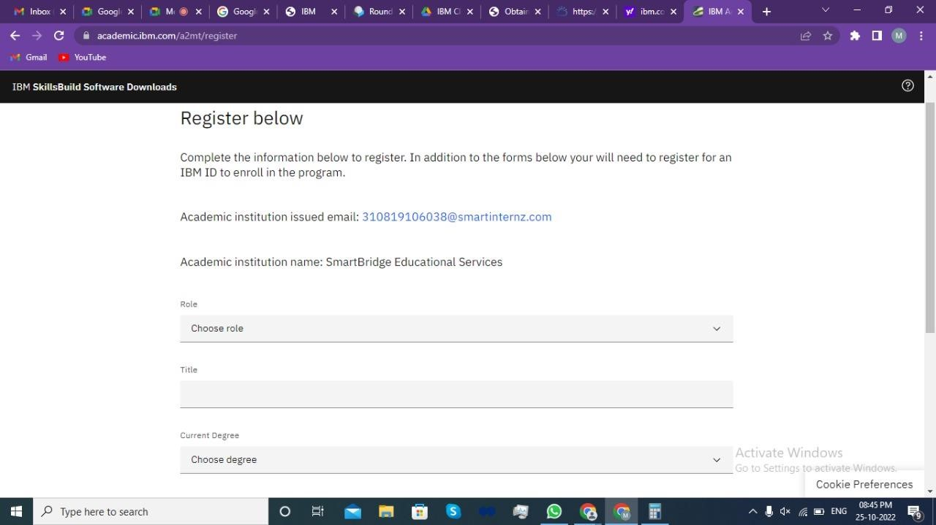

Step 18: Agree the Terms and Conditions and Register.

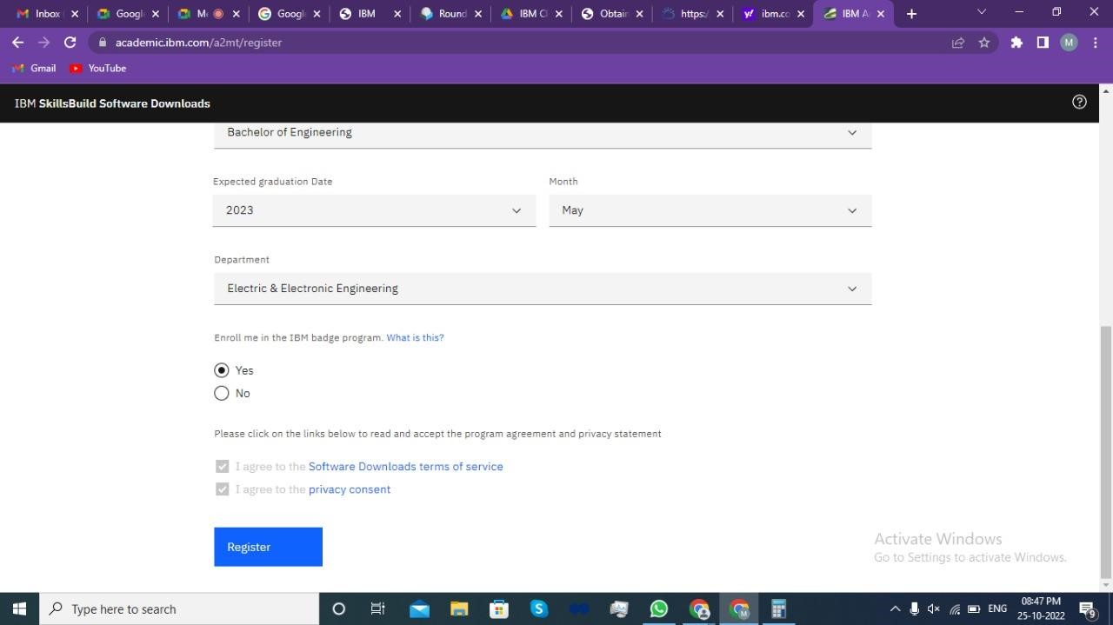

Step 19: Registration Success.

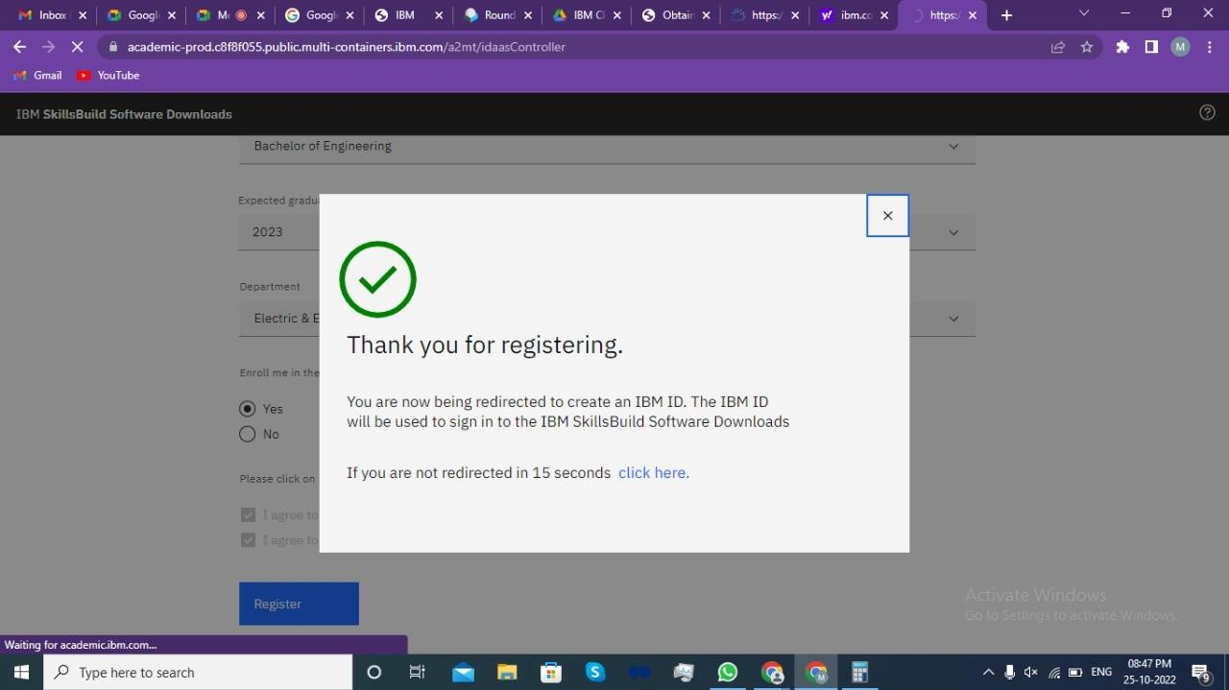

Step 20: Click on IBM Cloud.

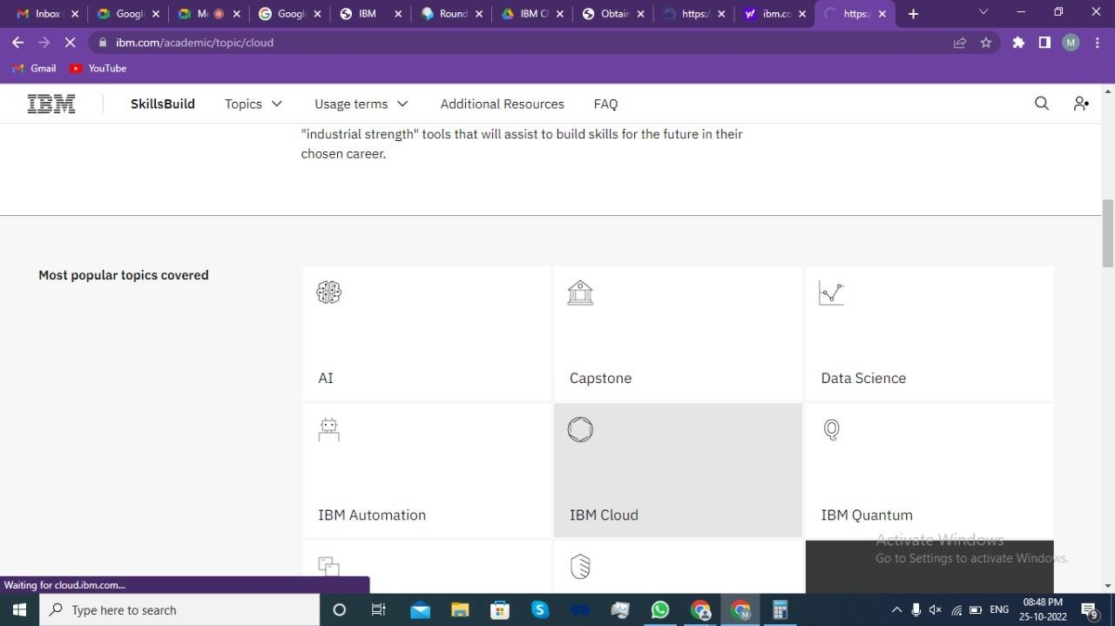

1: Go to Software and click on IBM cloud feature code.

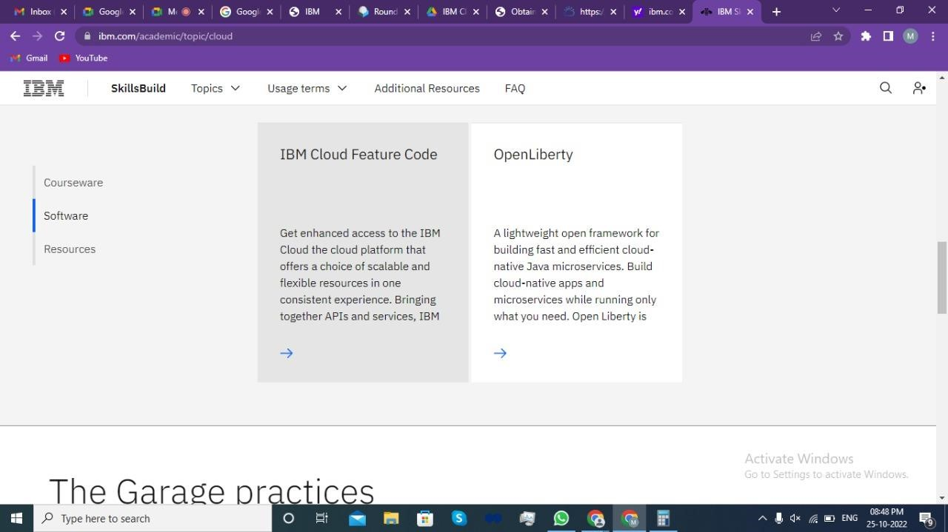

Step 22: Click on Request Feature Code.

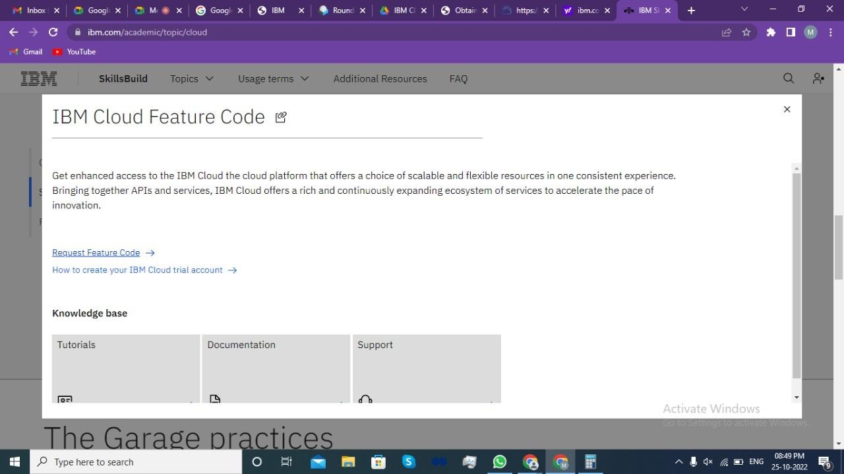

3: Copy the code.

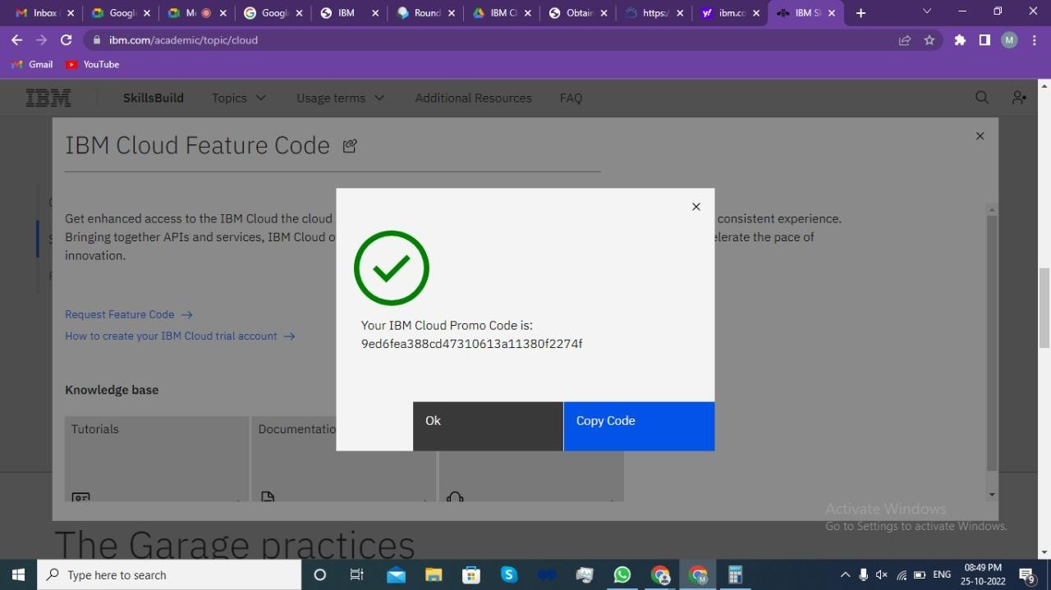

Step 24: Paste the Code and click on create account.

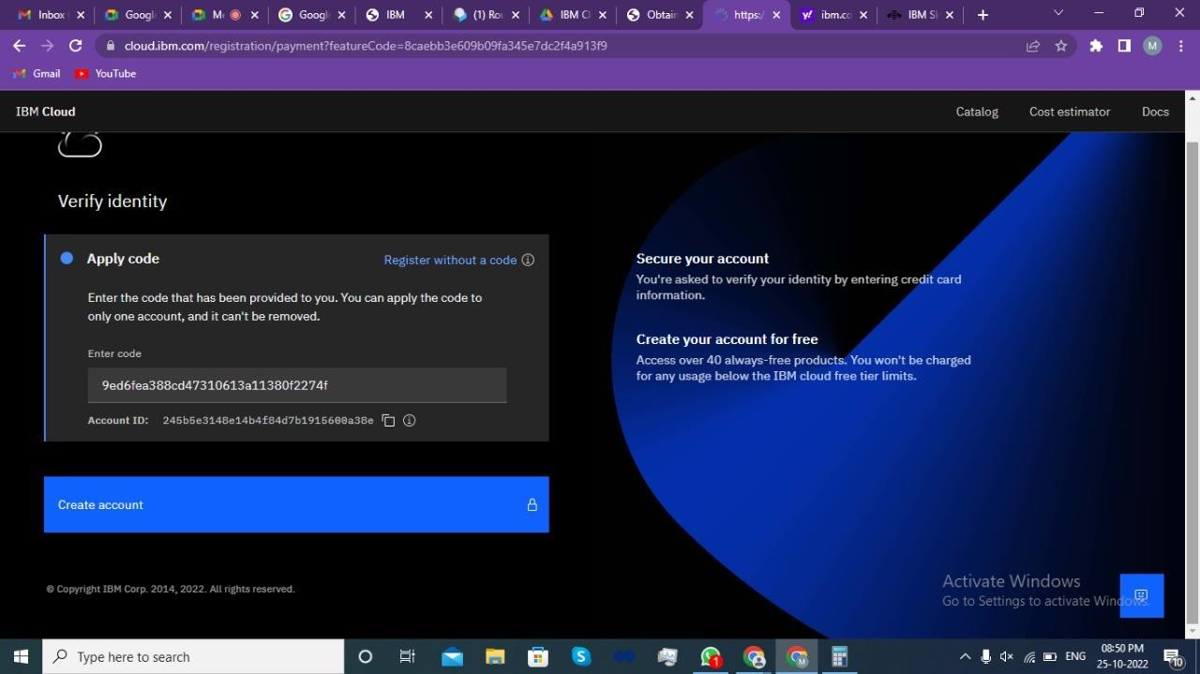

5: After Successfully creating the account you are redirected to the dashboard page of the IBM Cloud account.

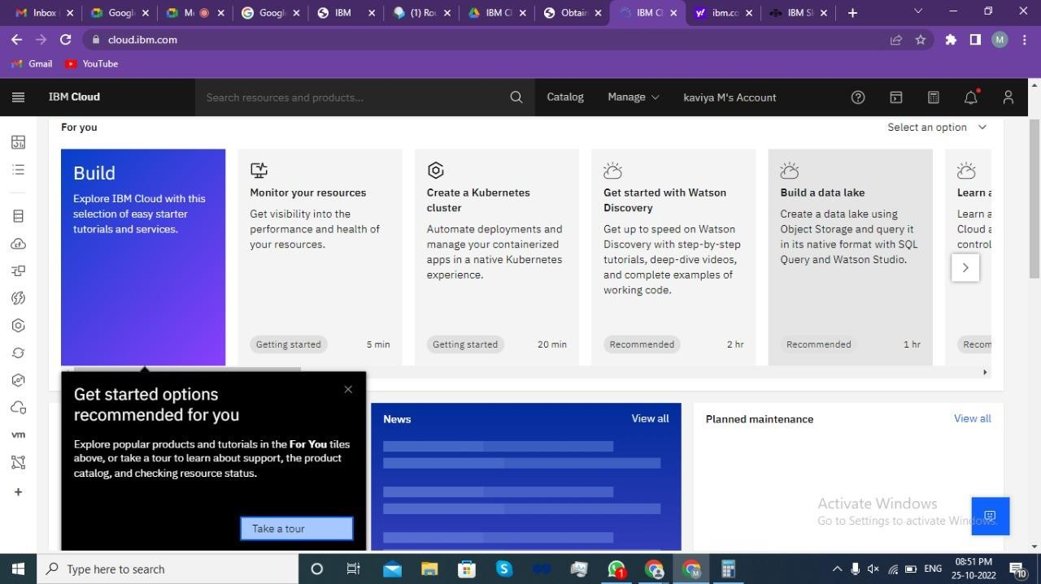

**Result:**

An IBM Cloud Service created Successfully.